CSA1704-ARTIFICAL INTELLIGENCE LAB
6. Write the python program for Vacuum Cleaner problem
AIM
To write a Python program to solve the Vacuum Cleaner problem using the Breadth-First Search (BFS) algorithm.

Objective

To implement the BFS search algorithm in Python to move a vacuum cleaner between two rooms and clean all dirty rooms until the goal state is reached.

Algorithm
• Define the initial state and goal state of the Vacuum Cleaner problem.
• Represent the state using the vacuum cleaner's location and the cleanliness of both rooms.
• Place the initial state into a queue.
• Remove the first state from the queue.
• Check whether both rooms are clean.
• If both rooms are clean, display the solution and stop.
• Otherwise, check the current location of the vacuum cleaner.
• If the current room is dirty, perform the SUCK operation.
• If the current room is clean, move the vacuum cleaner to the other room.
• Add the new unvisited states to the queue.
• Repeat Steps 4–10 until the goal state is reached.
• End the program.

Flowchart
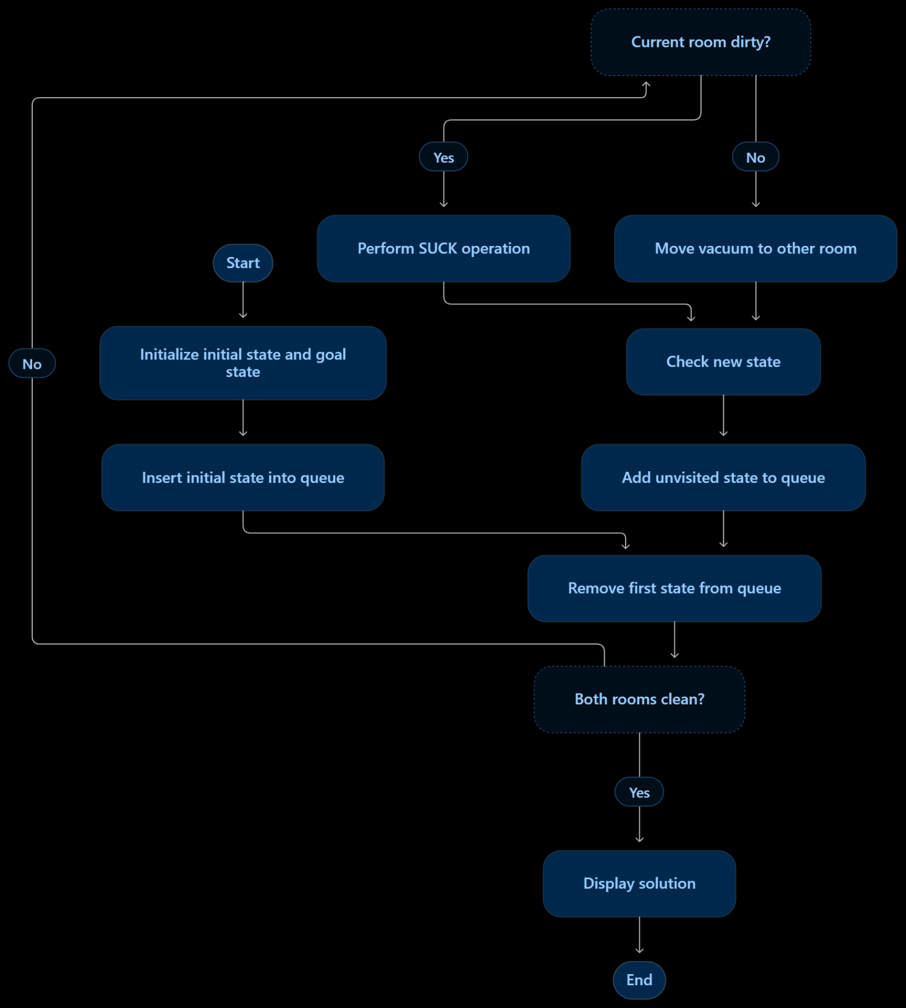

Code:

from collections import deque

start = ('A', 1, 1)

goal = (0, 0)

queue = deque([(start, [start])])

visited = set()

while queue:

state, path = queue.popleft()

pos, A, B = state

if A == 0 and B == 0:

print("Goal Reached!\n")

for step in path:

print(step)

break

if state in visited:

continue

visited.add(state)

if pos == 'A':

if A == 1:

new_state = ('A', 0, B)

if new_state not in visited:

queue.append((new_state, path + [new_state]))

new_state = ('B', A, B)

if new_state not in visited:

queue.append((new_state, path + [new_state]))

else:

if B == 1:

new_state = ('B', A, 0)

if new_state not in visited:

queue.append((new_state, path + [new_state]))

new_state = ('A', A, B)

if new_state not in visited:

queue.append((new_state, path + [new_state]))

OUTPUT
Goal Reached!
('A', 1, 1)
('A', 0, 1)
('B', 0, 1)
('B', 0, 0)
RESULT:

The Python program successfully solved the Vacuum Cleaner problem using the Breadth-First Search (BFS) algorithm and cleaned both rooms by performing the required operations.

CONCLUSION
The Vacuum Cleaner problem was successfully solved using the BFS algorithm in Python. The program explored the possible states, performed the cleaning operation and moved the vacuum cleaner between the two rooms until both rooms became clean. This demonstrates the application of AI search techniques in an intelligent agent environment.

